***Two Stroke Petrol Engine***

* **Introduction:**

Two Stroke Petrol Engine is also called Spark Ignition Engine .Because, it consist of

Ignition spark plug .All the process complete in two stroke .That is why it is called two Stroke engine.

* **Defination:**

“It is defined as the process in which two strokes required to complete one cycle”.

* **Parts list:**

1. **Spark plug:**

Spark plug creates the spark and burns the fuel.

1. **Cylinder:**

It consists of a piston. Piston moved in the Cylinder .When piston is below the exhaust port .The upper portion of cylinder called combustion space.

1. **Exhaust port:**

In exhaust port burn gasses are evolved.

1. **Carborator:**

Carborator is used to mix the mixture of petrol and air.

1. **Inlet port:**

The mixture of air and petrol enter the cylinder by inlet port.

1. **Transfer port:**

The mixture of air and petrol enter the combustion space by transfer port.

1. **Piston:**

Piston move up and down in the cylinder .Piston also compress the gasses and increase the pressure inside the cylinder.

1. **Connecting rod:**

Connecting rod connects crank shaft with piston.

1. **Crank shaft:**

Crank shaft turns the vibratory motion of piston into the rotator motion.

1. **Fins:**

Fins are used for air cooling.

**Working:**

When the engine is at rest then the mixture of air and petrol enter in cylinder by inlet port because the blue side has the large vacuum .Air and petrol mixed by Carborator . When engine starts work then piston moves upward and the gasses in compression region start compressed and spark plug delivered the spark and fire the air fuel and burn these gasses and piston moves downward rapidly due to spark plug .When piston move downward the exhaust port open and the same time transfer port is also open so the burn gasses exit by the exhaust port because exhaust port has low density due to high temperature and gasses moves from high density to low density .when the piston is upward position then inlet port open and mixture of air and petrol enter that is why piston moves upward due to inertia .During one rotation of crank shaft piston moves up and down and covered two stroke .

* **Cycle:**

* **Intake:**

In this process mixture of air and petrol enter by inlet port and enter into the blue part of cylinder transfer port is also open and this mixture transfer into the red area of cylinder, is called compression region .Due to inertia piston move up and transfer port now close and process is completed .In this process volume is high and pressure is low.

* **Compression:**

In this process mixture of air and petrol is compressed .Due to inertia when piston move up then compression is starts and pressure is increased and volume is decreased.

* **Ignition:**

Ignition process is very interesting .In ignition process spark plug delivered the spark and fires the gasses and gasses ignited .In this process the pressure is very high and volume is very low.

* **Power stroke:**

When the ignition process is complete then power process is starts .In this process piston move downward due to power of spark plug and ignition gasses .In this process the volume is increasing and pressure is decreasing.

* **Exhaust stroke:**

In exhaust stroke the gasses are exit by exhaust port. In this process transfer and exhaust port both are open and burn mixture exit to the exhaust port due to low density.

* 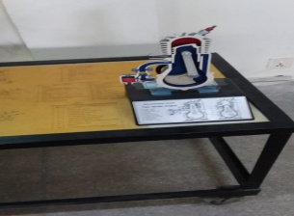**Diagram:**

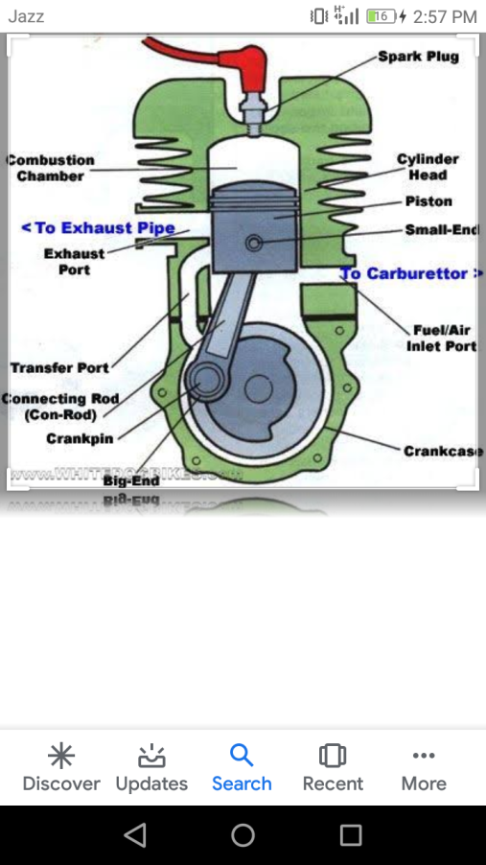 Label diagram

* **Graphical Representation:**

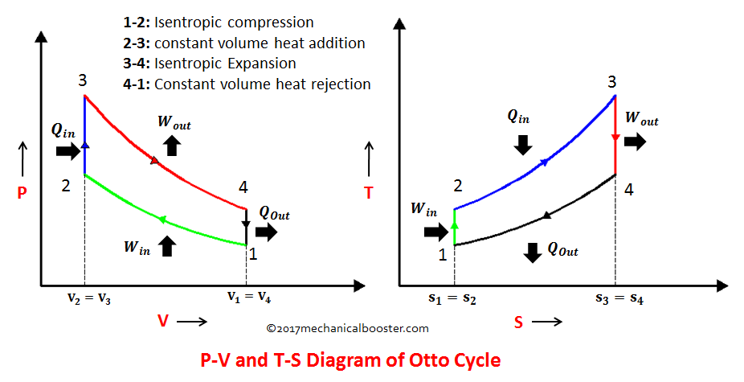

* **Application:**

Two cycle engines are useful in applications such as chainsaws, ships, outboards, lawnmowers and motorcycles etc.

* **Conclusion:**

We learned the working of two stroke petrol engine. How we used it in different purpose .Where it is used its advantages and disadvantages.